• Exercise 10: Draw a flowchart for one of these activities. Then compare your completed

flowchart with other students

**Erwan Majid/08/2i**

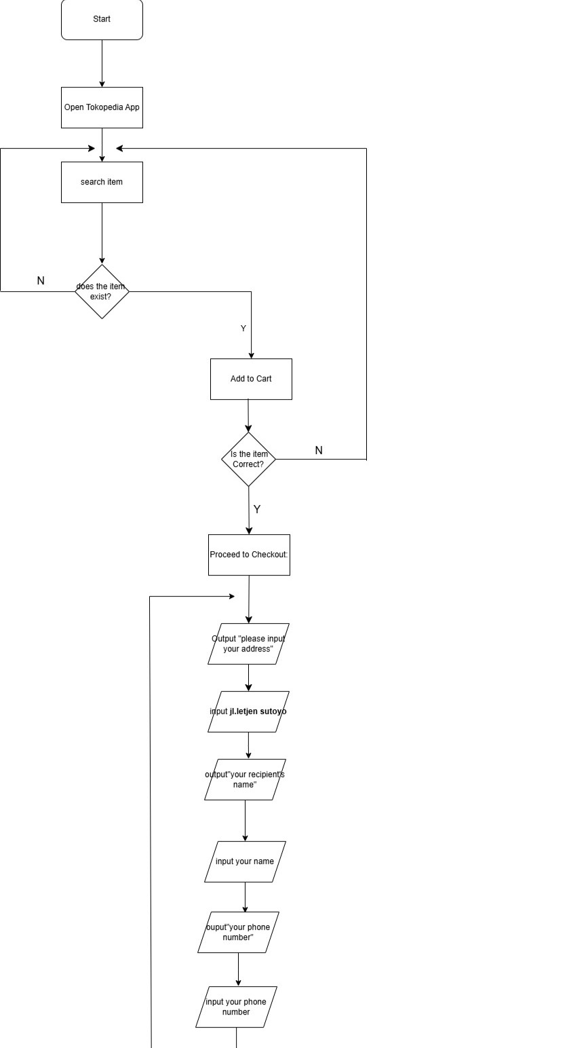Buy Item From Tokopedia

